Clean Code Principles - Write Fast and Independent Tests
# Source: AI Source: Provided by: [Data Path: Persons Table -> ID Column: 1, Name_En Column: Motasem Essam] -> From: [Chatgpt (GPT‑5 Mini)] on [12/9/2025]
Tests should be fast to run and independent from each other so they can be executed anytime with reliable results.
👉 Good tests give you confidence to change and refactor code safely.

🔑 Why It Matters
# Source: AI Source: Provided by: [Data Path: Persons Table -> ID Column: 1, Name_En Column: Motasem Essam] -> From: [Chatgpt (GPT‑5 Mini)] on [12/9/2025]
- Fast tests encourage frequent execution
- Independent tests avoid unexpected failures
- Easier debugging when a test fails
- Supports continuous integration and delivery

❌ Bad Example (Slow & Dependent Tests)
# Source: AI Source: Provided by: [Data Path: Persons Table -> ID Column: 1, Name_En Column: Motasem Essam] -> From: [Chatgpt (GPT‑5 Mini)] on [12/9/2025]
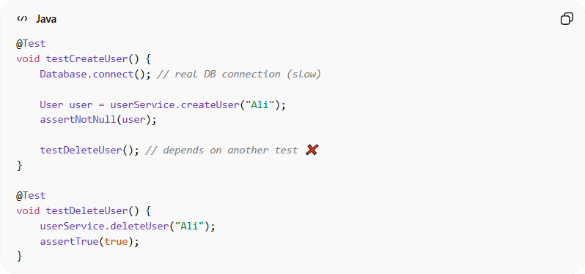
@Test
void testCreateUser() {
Database.connect(); // real DB connection (slow)

User user = userService.createUser("Ali");
assertNotNull(user);

testDeleteUser(); // depends on another test ❌
}

@Test
void testDeleteUser() {
userService.deleteUser("Ali");
assertTrue(true);
}
👉 Problems:
- Uses real database → slow
- One test depends on another → fragile
- Hard to run tests in isolation

✅ Good Example (Fast & Independent Tests)
# Source: AI Source: Provided by: [Data Path: Persons Table -> ID Column: 1, Name_En Column: Motasem Essam] -> From: [Chatgpt (GPT‑5 Mini)] on [12/9/2025]
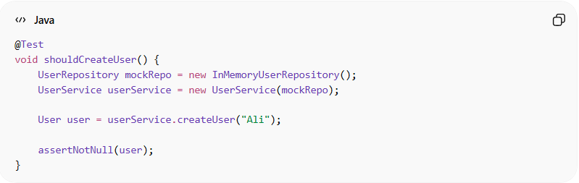
@Test
void shouldCreateUser() {
UserRepository mockRepo = new InMemoryUserRepository();
UserService userService = new UserService(mockRepo);

User user = userService.createUser("Ali");

assertNotNull(user);
}
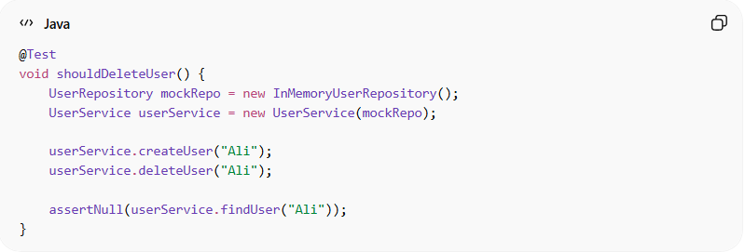
@Test
void shouldDeleteUser() {
UserRepository mockRepo = new InMemoryUserRepository();
UserService userService = new UserService(mockRepo);

userService.createUser("Ali");
userService.deleteUser("Ali");

assertNull(userService.findUser("Ali"));
}
👉 Benefits:
- No external dependencies (fast)
- Each test is independent
- Easy to understand and debug

⚡ How to Make Tests Fast
# Source: AI Source: Provided by: [Data Path: Persons Table -> ID Column: 1, Name_En Column: Motasem Essam] -> From: [Chatgpt (GPT‑5 Mini)] on [12/9/2025]
- Avoid real databases, APIs, or file systems
- Use mocks or in-memory implementations
- Keep tests small and focused

🔗 How to Make Tests Independent
# Source: AI Source: Provided by: [Data Path: Persons Table -> ID Column: 1, Name_En Column: Motasem Essam] -> From: [Chatgpt (GPT‑5 Mini)] on [12/9/2025]
- Each test sets up its own data
- No shared state between tests
- No reliance on execution order

💡 Key Idea
# Source: AI Source: Provided by: [Data Path: Persons Table -> ID Column: 1, Name_En Column: Motasem Essam] -> From: [Chatgpt (GPT‑5 Mini)] on [12/9/2025]
A test should run quickly and correctly no matter when or how many times you run it.

🚫 Common Mistakes
# Source: AI Source: Provided by: [Data Path: Persons Table -> ID Column: 1, Name_En Column: Motasem Essam] -> From: [Chatgpt (GPT‑5 Mini)] on [12/9/2025]
- Tests depending on other tests
- Using real external systems (DB, API) unnecessarily
- Sharing data between tests
- Writing large, slow tests

🧾 Summary
# Source: AI Source: Provided by: [Data Path: Persons Table -> ID Column: 1, Name_En Column: Motasem Essam] -> From: [Chatgpt (GPT‑5 Mini)] on [12/9/2025]
Fast and independent tests help you:
- Run tests frequently
- Detect issues early
- Refactor code safely
- Build reliable software

